**MINI PROJECT #1**

**ANALYTICAL MODEL TO PREDICT CREDIT RATING USING R**

**TEAM MEMBERS:**

**SRAVYA BOBBA**

# 

# Executive Summary:

We were given a csv file with 255 records and 19 variables. Our goal is to build the efficient model which would be able to predict Credit Rating based on the given data. We started with cleansing data including removal of outliers which reduced our records from 255 to 130.  
We built models like Logistic regression and CART (Classification and Regression Trees) which can predict required dependent variable Credit-Rating based on subset of significant independent variables with considerable accuracy. We refined, tested and verified our models for accuracy to predict Credit-Rating.

Table of Contents

Executive Summary: 2

Preliminaries section: 4

Data Cleansing: 4

Decision Variable: 5

Independent variables: 5

Correlation: 6

Graphs: 7

Logistic Regression: 17

Data splitting: 17

Refining the model: 18

Accuracy: 19

Results: 19

Classification and Regression Trees: 21

Data splitting: 21

Impact of minbucket: 21

Cross-validation: 24

Comparison of accuracy achieved with baseline model: 24

Results: 24

Conclusion: 25

**List of Figures and Tables**

Figure 1-This shows raw data with n/a values and outliers 5

Figure 2 - Scatter Plot between Monthly Expense and Monthly income 8

Figure 3 - Scatterplot between Average and LoanSizeAvg 9

Figure 4 - Scatterplot between Average and LoanSizeAvg after removing outliers 10

Figure 5 - Histogram of LoanPeriod 11

Figure 6 - Histogram of LoanSizeAvg 12

Figure 7 - Histogram of Age 13

Figure 8 - Histogram of MonthlyPayment 14

Figure 9 - Box Plot between MonthlyIncome and LoanPeriodMonths 15

Figure 10 - Box Plot between Age and MonthlyPayment 16

Figure 11 - Box Plot between Age and LoanPeriodMonths 17

Figure 12 - Summary of Crating after data cleansing and removing outliers 18

Figure 13 - Baseline logistic regression model with insignificant variables 19

Figure 14 - Refined Logistic regression model 21

Figure 15 - AUC for Logistic Regression 21

Figure 16 - Tree with minbucket as 5 23

Figure 17 - Tree with minbucket as 10 23

Figure 18 - Tree with minbucket as 15 24

Figure 19 - Random Forest 24

Table 1-Correlation 7

Table 2 - Accuracy 26

Preliminaries section:

Here, we need to predict credit rating for different individuals which is a measure of reliability

Data Cleansing:

The csv file provided has a lot of missing data, this missing data must be filled with appropriate values by analyzing other independent variables or the records corresponding to the missing data cells should be deleted.



Figure 1-This shows raw data with n/a values and outliers

### Decision Variable:

* Credit Rating: This column has 3 not available values; these cells have been removed from the csv file. After the n/a records have been deleted, the numbers in this column are organized into 0 and 1. 0 is given to credit rating less than or equal to 2 and 1 is given to credit rating greater than 2.

Credit rating has been factored as a decision variable.

### Independent variables:

* + Age: The age column has 21 not available values and these cells are filled with median age that is 44.
  + Monthly Payment: This column has 118 not available values and the records corresponding to these values have been deleted to improve the csv file.
  + Monthly Income: This column has 13 not available values and the records to these values have been deleted to improve the csv file.
  + Participates in community: This column has 15 not available values and these values have been assigned a new value that is the median value 2.
  + Social Fabric: This column has 14 not available values and these values have been assigned a new value that is the median value 3.
  + Per Capita available income: This column has 41 not available values and is being assigned a new value that is 0.
  + Available Income: This column has 41 not available values and is being assigned a new value that is 0. The value is given as 0 as it is the difference between monthly income and monthly expense.
  + The records corresponding to not available values in Years at this house, Main household, Monthly Expenses and Loan Opinion are automatically deleted as the above changes are made.
  + We have identified that Per Capita Available Income, Available Income and UserID don’t affect the data or help us to analyze the data in a better way and hence they have been set to null.

# Correlation:

We have performed 4 correlation functions to analyze the significance of independent variables with other independent variables.

Table 1-Correlation

|  |  |  |  |  |
| --- | --- | --- | --- | --- |
| Correlation | Variable 1 | Variable 2 | Percentage | Comments |
| Correlation 1 | Age | LoanSizeAvg | 3% | Age is inversely proportional to LoanSizeAvg.  However, 3% is insignificant. |
| Correlation 2 | MonthlyIncome | MonthlyPayment | 51% | Directly proportional and significant. |
| Correlation 3 | PerCapitaAvailableIncome | UpfrontPaymentAvg | 19% | Directly proportional and insignificant. |
| Correlation 4 | MonthlyExpense | LoanSizeAvg | 72% | Directly proportional and significant. |

## Graphs:

* Scatterplot

First, we have plotted the graph between the variables MonthlyIncome and MonthlyExpense and we can observe from this graph that if MonthlyIncome is equal to MonthlyExpense, the point falls on the diagonal and the points above the diagonal are those where MonthlyExpense is greater than MonthlyIncome and the AvailableIncome becomes negative.

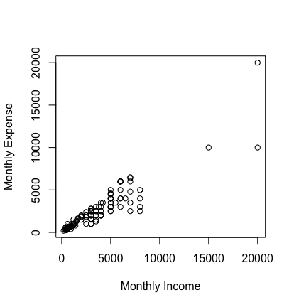

Figure 2 - Scatter Plot between Monthly Expense and Monthly income

Second, we have plotted age against LoanSizeAvg and we have observed that people between age 35-50 have taken majority of the loans. The outliers that we can find here are Age greater than 80 and LoanSizeAvg greater than $40,000 and hence these outliers should be removed from the complete file, that is the csv file.



Figure 3 - Scatterplot between Average and LoanSizeAvg



Figure 4 - Scatterplot between Average and LoanSizeAvg after removing outliers

* Histogram

Here we can observe the frequency of the independent variables and analyze how they can affect the data. First, consider the frequency of LoanPeriod. Here we can predict from the histogram that the number of loans sanctioned are higher for loan period less than 2 and greater than 11.



Figure 5 - Histogram of LoanPeriod

In the next histogram plotted for LoanSizeAvg, the frequency of Loan sanctioned is higher when the LoanSizeAvg is less than $5000.



Figure 6 - Histogram of LoanSizeAvg

In the next histogram plotted for Age, the frequency of Loan sanctioned is higher when the Age is between 35-50.



Figure 7 - Histogram of Age

In the next histogram plotted for MonthlyPayment, the frequency of Loan sanctioned is higher when the LoanSizeAvg is less than $5000.



Figure 8 - Histogram of MonthlyPayment

* Box Plot

First, Box Plot plotted between MonthlyIncome and LoanPeriodMonths predicts that people with lower monthly income take a loan for longer loan periods.



Figure 9 - Box Plot between MonthlyIncome and LoanPeriodMonths

Second, Box Plot plotted between Age and MonthlyPayment predicts that lower monthly payments are made by people whose age is greater than 40 and higher monthly payments are made by people whose age is between 25-35.



Figure 10 - Box Plot between Age and MonthlyPayment

Next, Box Plot between LoanPeriodMonths and Age shows that people whose age is greater than 45 have higher LoanPeriodMonths.



Figure 11 - Box Plot between Age and LoanPeriodMonths

# Logistic Regression:

Data splitting: We need to split the data available into training and testing dataset while doing logistics regression (2/3rd data as training dataset and 1/3rd as testing dataset using R). We would need training dataset to build the tree model and then we can test the model on test dataset to verify the reliability of our model. This would be very like what we did in the logistics regression.



Figure 12 - Summary of Crating after data cleansing and removing outliers

After data has been cleansed completely, we can consider this as the baseline data. We built a logistic regression model on the baseline data to create a baseline logistic regression model.



Figure 13 - Baseline logistic regression model with insignificant variables

* Initially we have 130 records with 16 variables.
* The training set has 87 records with 16 variables and the testing set has 43 records with 16 variables.

## 

## Refining the model:

* After building the logistic regression model we can see a lot of insignificant variables in the baseline logistic regression model and these insignificant variables must be removed to improve the model and its accuracy.
* Variables that have been removed to improve the model and accuracy are:
  + FamilySize
  + Age
  + MainHousehold
  + YearsAtThisHouse
  + Sex
  + ParticipatesInCommunity

Accuracy:

* After removing the above insignificant variables, we can see that the accuracy of the model on training set has been its highest at 74.41%
* After removing the above insignificant variables, we can see that the accuracy of the model on testing set has been its highest at 79.06%

## Results:

* After removing some of the insignificant variables we have built the required model to predict credit rating.
* Although we still don’t have all variables as significant, further refining of the model could result in the overfitting of the model.



Figure 14 - Refined Logistic regression model



Figure 15 - AUC for Logistic Regression

# Classification and Regression Trees:

Data splitting: We have already split the data available into training and testing dataset while doing logistics regression (2/3rd data as training dataset and 1/3rd as testing dataset using R). We would need training dataset to build the tree model and then we can test the model on test dataset to verify the reliability of our model. This would be very like what we did in the logistics regression.

Impact of minbucket: Minbucket could be defined as the minimum number of observations in any terminal node in our tree. We may choose different values of minbucket based on number of observations. Here, we just have 87 observations in our training dataset, thus we can try following values of minbucket.

**1. Taking minbucket as 5:** This has given accuracy of 69.77% which is good but plots a complicated diagram with many leaves. We won’t be using this value of minbucket as this is complicated to understand with higher number of leaves and we can establish a better trade-off of complexity and accuracy.

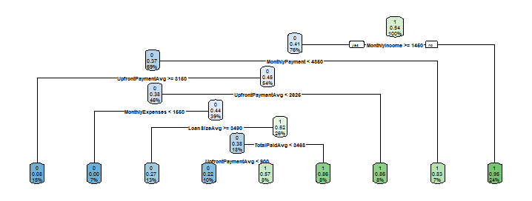

Figure 16 - Tree with minbucket as 5

**2. Taking minbucket as 10:** This has given accuracy of 58.14% which is average but plots a better diagram with some leaves. Here, accuracy is really low so we won’t be using this value as well.

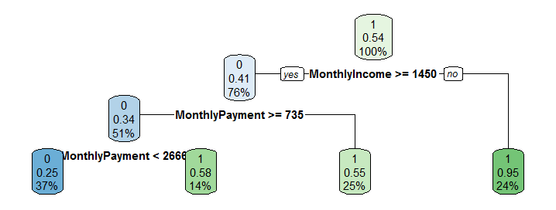

Figure 17 - Tree with minbucket as 10

**3. Taking minbucket as 15:** This has given accuracy of 65.12% which is also good but plots a simple and neat diagram with few leaves. This provides a very good combination of accuracy and number of leaves in the diagram having less complexity.

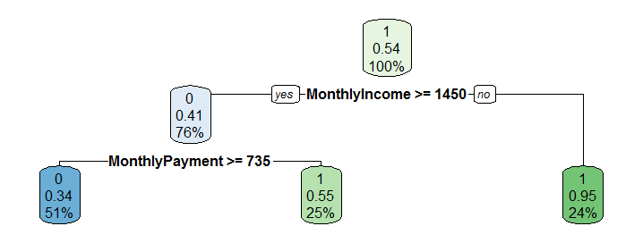

Figure 18 - Tree with minbucket as 15



Figure 19 - Random Forest

Cross-validation: It could be defined as k-fold cross-validation where the samples are randomly partitioned into k sets (called folds) of roughly equal size. Then, we fir a model using all the samples except the first subset. For our case, we defined 10 folds as having fewer observations of our training dataset. Thus, we would have around 8 folds to compare results.

Cross-validation would consider a cp value (defined by us with minimum, maximum and interval value) which would determine different accuracies for different test cases with changing cp value as a factor of prediction. Then, we would choose best cp value for defining our model based on training dataset.

After building a model using best cp value and accuracy, we build another model considering another cp value which is close to best accuracy giving cp value (but having relatively lower accuracy). Now, we would test this model on our testing dataset to verify the quality of the new model.

Comparison of accuracy achieved with baseline model: Baseline model is very simple which takes correct matches of values only in account. We already determined accuracy of baseline model in logistics regression and we can compare it with accuracy achieved with cross validation. We see that accuracy is better in cross-validation (67.44%) than same in baseline model (52.27%).

Results: Using tree, we built models like CART (Classification and Regression Trees), RandomForest model, and then did cross-validation experiment. We can compare results with the help of following table.

Table 2 - Accuracy

|  |  |  |
| --- | --- | --- |
| **Model Used** | **Parameters used** | **Accuracy** |
| **CART** | minbucket (15) | 65.12% |
| **RandomForest** | ntree (200),  nodesize (20) | 65.12% |
| **Cross-validation** | Number of folds (10) | 67.44% |
| **Baseline method** | NA | 52.27% |

# Conclusion:

With the given set of data, we can introduce different models like Logistic Regression and CART with good accuracy. We built models using 2/3rd of data available and then we improved it. Then we tested our models on rest of the data (testing data) and found that it could predict Credit Rating for different individuals with good accuracy.

Although we may argue that we had few observations to introduce the model. Thus, we could not be relying too much on any of the model, but considering both Logistic Regression and CART models we are likely to predict Credit Rating accurately.

We suggest company to use a combination of both models given so that errors would be minimized. However, we strongly recommend getting more data to make prediction models strong.